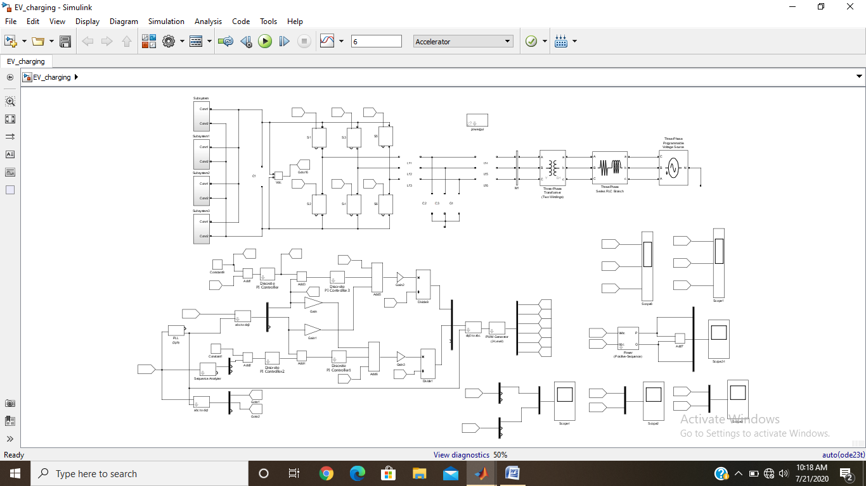

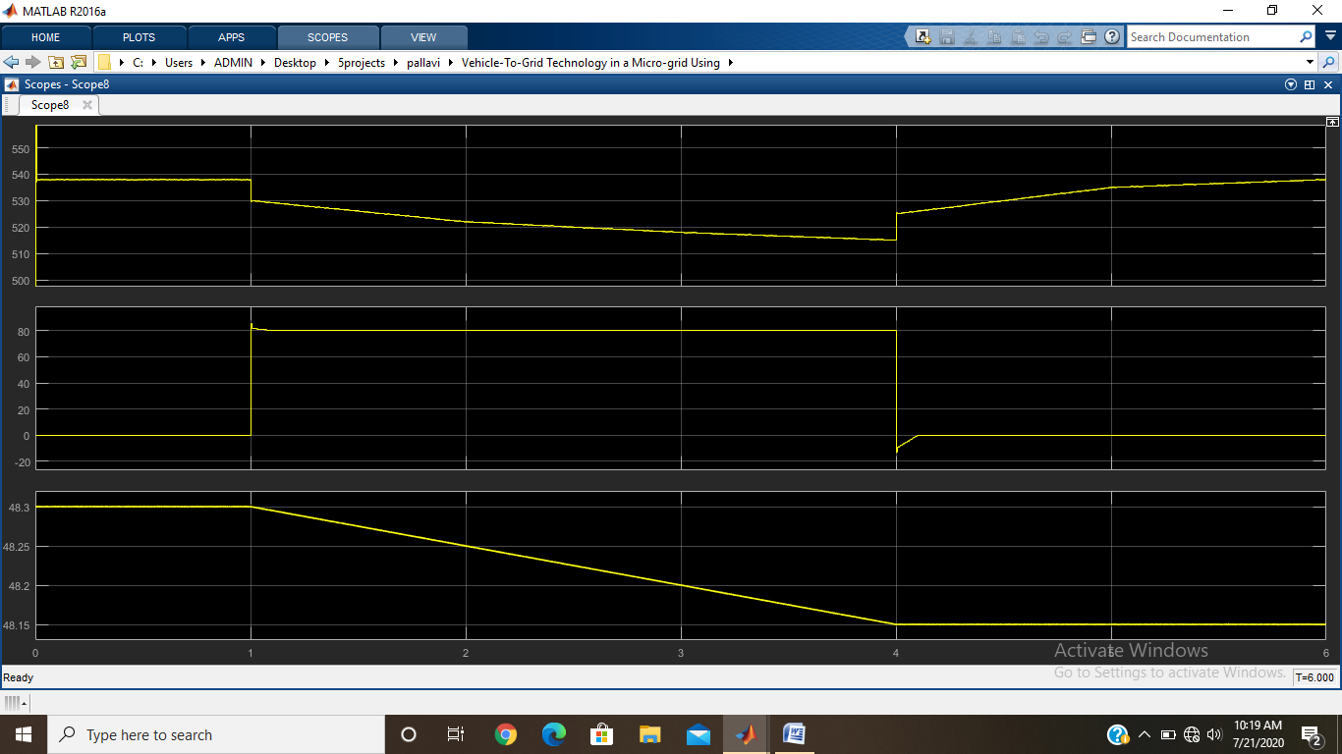

Fig. 6. Voltage, current, and SOC of EV1 battery during V2G operation

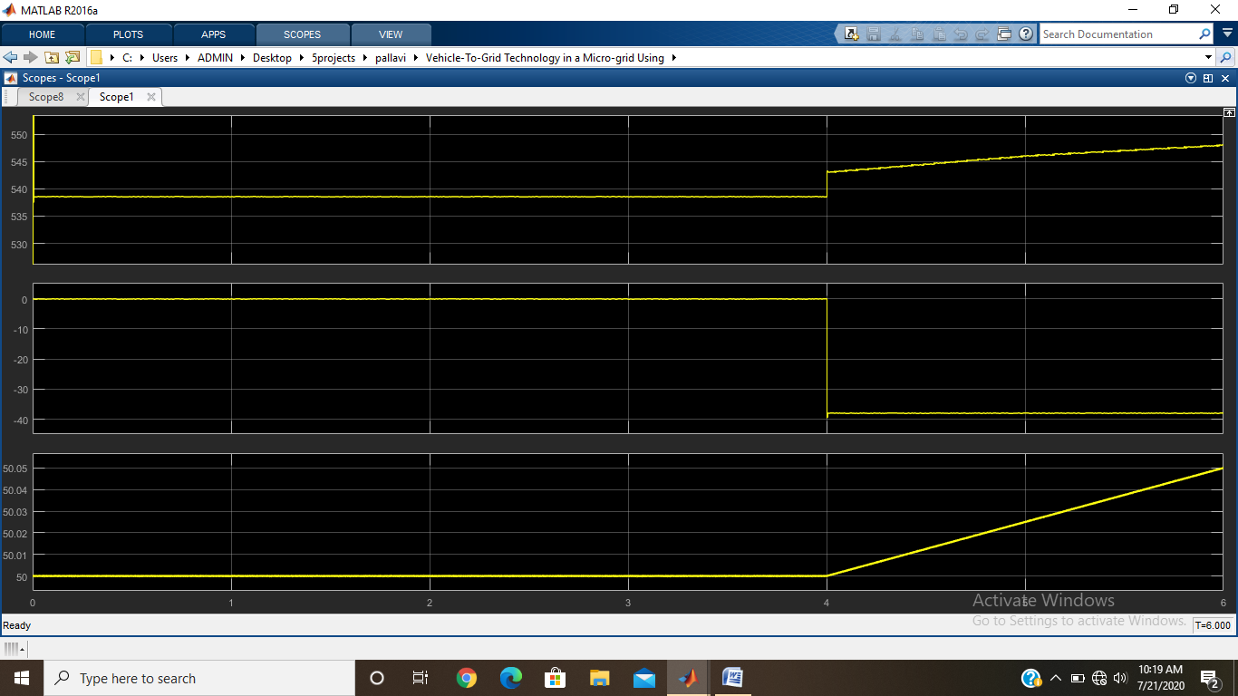

Fig. 7. Voltage, current, and SOC of EV2 battery during G2V operation

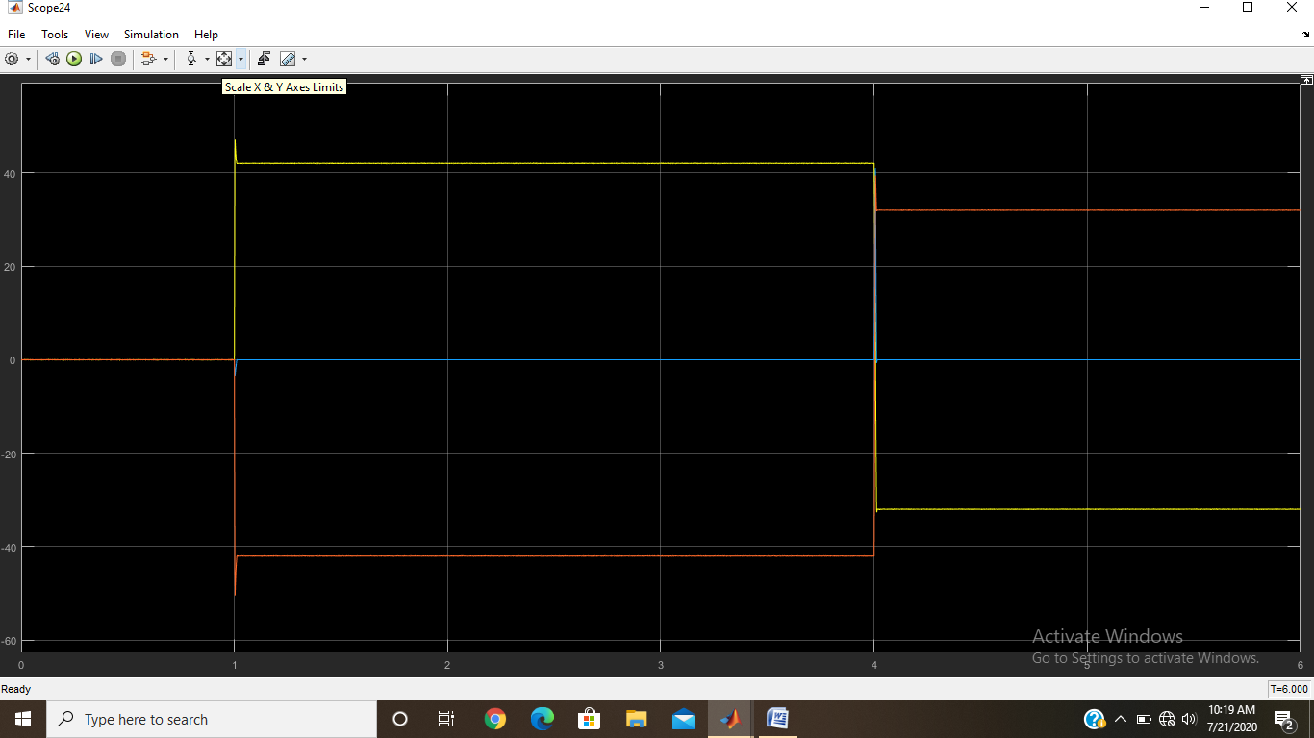

Fig. 8. Active power profile of various components in the system

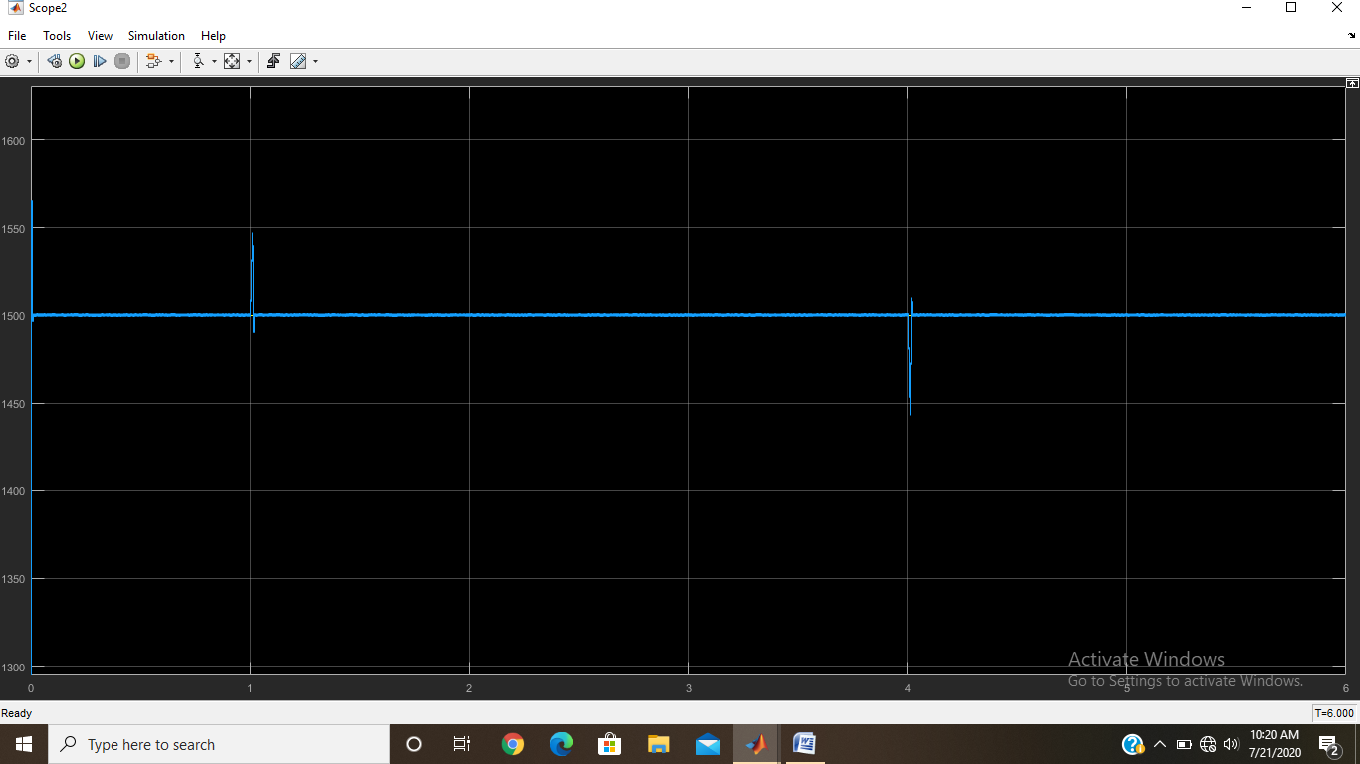

Fig. 9. Variation in dc bus voltage

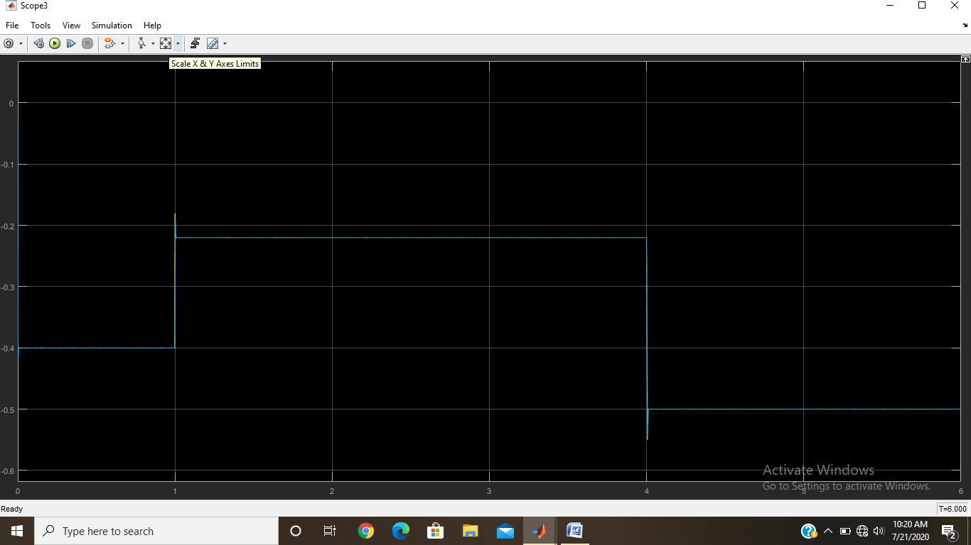

Fig. 10. Reference current tracking by inverter controller

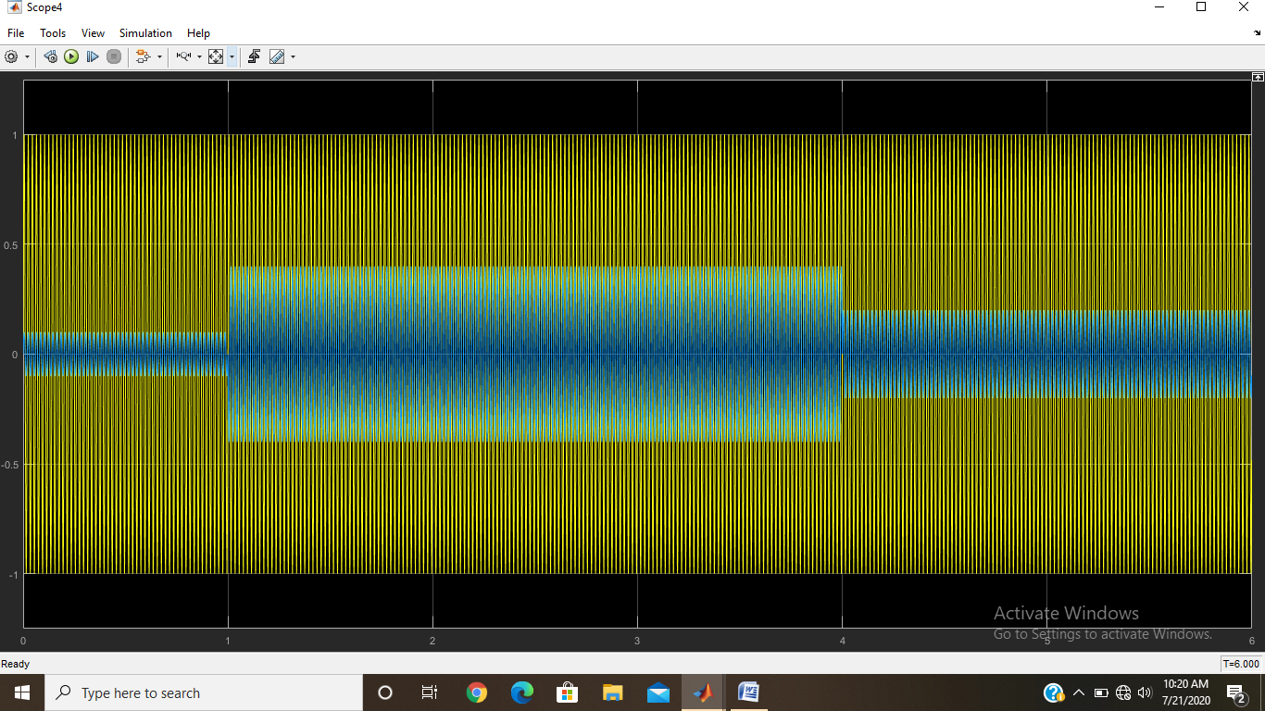

Fig. 11. Grid voltage and grid injected current during V2G-G2V operation

